PS-2252-6L1U PRIMARY Firmware Spec.

Revision | Date | Author | Comments
X01 | 10/27/2017 | davidchchen | Initial version

PS-2252-6L1U PRIMARY FIRMWARE SPEC. 1
1. DIAGRAM 3
2. TARGET MICRO-P REQUIREMENT 3
3. GENERAL MICRO-P PINOUT DESCRIPTION 3
4. I/O PINS 4
4.1 INPUT PINS 4
4.2 OUTPUT PINS 4
5. ANALOG TO DIGITAL MEASUREMENT 4
6. A/D DETECTION METHOD 5
6.1 AC INPUT 5
6.1.1 AC SLOW-SPEED DETECTION 5
6.2 DC INPUT 5
6.3 PFC OUTPUT 5
7. PROTECTION 5
7.1 PFC PROTECTION 5
7.1.1 BUS VOLTAGE 5
7.1.2 OTP 5
7.1.3 INPUT VOLTAGE 6
8. PFC START TIME SEQUENCE 7
9. OTHER CONTROL 8
9.1 RS232 COMMUNICATION 8
9.1.1 SETTING 8
9.1.2 PROTOCOL 8

Diagram
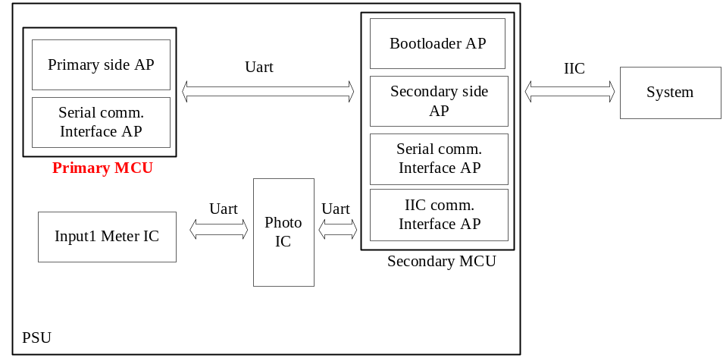

Target micro-P requirement
- Microcontroller: Freescale MC9S08QG4
- Internal Crystal: 32KHz
- FLL : 8MHz
- Watchdog : Enable
- Code Protect : Disable

GENERAL micro-p pinout description
Pin # | Pin Name | Connect to | Type | Function Description
1 | PTA5 | PTA5 | Reset | MCU reset pin.
2 | PTA4 | PTA4 |  | FW upgrade.
3 | VDD | 3.3V_P | Power | Connect to +3.3V.
4 | VSS | GND | Power | GND.
5 | PTB7 | RELAY_DRV | Output , I/O | PFC Output Relay Driver
6 | PTB6 | PFC_ADJUST | Output , I/O | Control PFC Output Voltage.
7 | PTB5 | PFC_STB_MCU | Output , I/O | Inform Sec. MCU PFC Bus is too Low.
8 | PTB4 | AC_OK | Output , I/O | AC_OK
9 | PTB3 | PFC_OK_MCU | Output , I/O | Inform Sec. MCU PFC is OK or Not
10 | PTB2 | PFC_ON | Output , I/O | Control PFC on/off
11 | TX | MCUP_TX | Uart | UART transmitter (To Sec. side).
12 | RX | MCUP_RX | Uart | UART receiver (To Sec. side).
13 | PTA3 | VAC_DET | Input , I/O | Detect Vin Brown In/Out
14 | PTA2/AD2 | T_PRI | A/D | Primary Temperate sensor.
15 | PTA1/AD1 | RECT_AC_SENSE | A/D | Vin input voltage
16 | PTA0/AD0 | PFC_OUT_MCU | A/D | PFC Output voltage

I/O PINS

Input pins
Pin # | Pin name | Initial State | Connect to | I/O Level definition
13 | PTA3 | H | VAC_DET | Logic 0 : Brown in  Logic 1 : Brown out

Output pins
Pin # | Pin name | Initial State | Connect to | I/O Level definition
5 | PTB7 | L | RELAY_DRV | Logic 0 : Disable  Logic 1 : Enable
6 | PTB6 | H | PFC_ADJUST | Logic 0 : PFC Adjust OFF  Logic 1 : PFC Adjust ON
7 | PTB5 | L | PFC_STB_MCU | Logic 0: PFC STB Not OK  Logic 1: PFC STB OK
8 | PTB4 | H | AC_OK | Logic 0 : AC OK  Logic 1 : AC Not OK
9 | PTB3 | H | PFC_OK_MCU | Logic 0 : PFC OK  Logic 1 : PFC Not OK
10 | PTB2 | L | PFC_ON | Logic 0 : Disable  Logic 1 : Enable

ANALOG TO DIGITAL MEASUREMENT
Pin # | Pin Name | Connect to | Scale
14 | PTA2/AD2 | T_PRI | 10K NTC
15 | PTA1/AD1 | RECT_AC_SENSE | 0Vac/0V ~ 321Vac/3.3V  or  0Vdc/0V ~ 454Vdc/3.3V
16 | PTA0/AD0 | PFC_OUT_MCU | 0Vi/0V ~ 472Vi/3.3V
- Resolution: 10-bits , reference voltage 3.3V.

A/D Detection Method

AC input

AC Slow-Speed detection
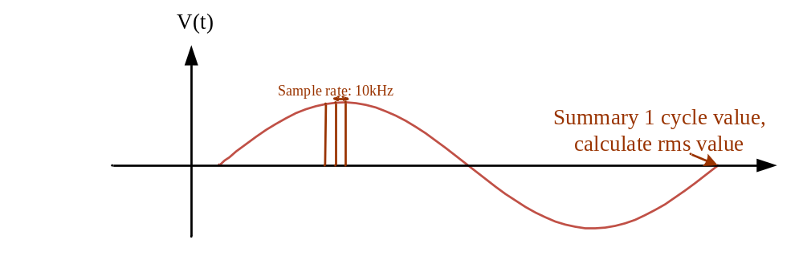
- x₁、x₂... x_{n} are sampling points in one period of input AC source and captured in the fixed rate (sampling frequency fs is 10kHz )
- Estimated voltage in Peak value is calculated by Vin.

DC input
- Digital filter, Sample rate: 2kHz
- DC input low pass filter: 100Hz

PFC output
- Digital filter, Sample rate: 2kHz
- PFC bus low pass filter: 100Hz

PROTECTION

PFC Protection

BUS Voltage
Bus Detection | FW Delay Time | Value | Protect
PFC Bus voltage – OVP - Low | 120ms | 450v | Disable PFC_OK, PFC disable ,Latch PFC and 12 main Vout
PFC Bus voltage – OVP - High | 2ms | 460v | Disable PFC_OK, PFC disable ,Latch PFC and 12 main Vout
PFC Bus voltage – UVP - Drop | 1ms | 335/330v | Disable PFC_OK, auto restart

OTP
Temp Detection | Delay time | Value | Recovery Value | Protect
PFC Over temp | 10s | 110C | 60C | Disable PFC_OK, wait Recovery value

Input Voltage
Input Detection | Delay time | Value | Recovery Value | Protect
Vin OVP - AC | 72ms | 295V | 264V | PFC Relay Turn off, PFC not OK, PFC disable. Auto Restart.
Vin OVP - DC | 72ms | 310V | 305V | PFC Relay Turn off, PFC not OK, PFC disable. Auto Restart.
Vin UVP - AC | 2ms | 157V | 174V | PFC Relay Turn off, PFC not OK, PFC disable. Auto Restart.
Vin UVP - DC | 2ms | 167V | 184V | PFC Relay Turn off, PFC not OK, PFC disable. Auto Restart.
- PFC Recovery time please ref. to 8. PFC START TIME SEQUENCE

PFC START TIME SEQUENCE
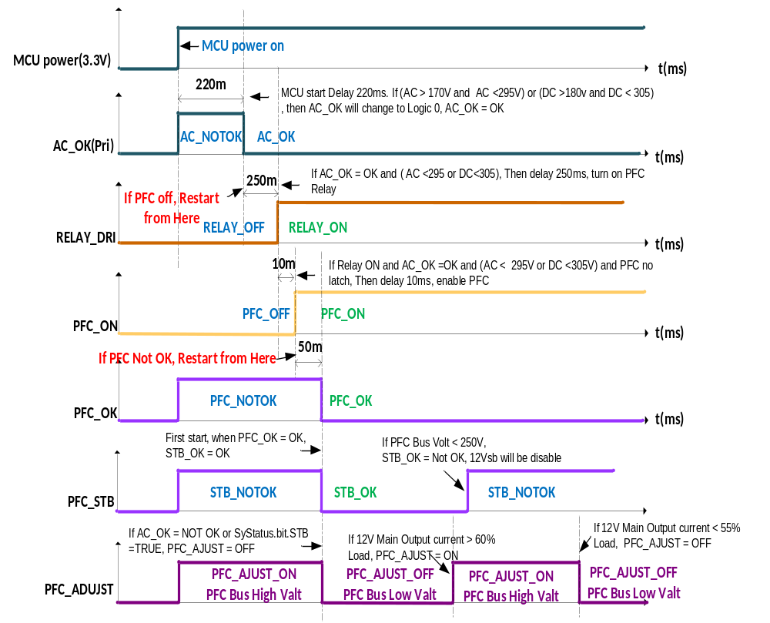

OTHER CONTROL

RS232 communication

Setting
9600bps, N, 8, 1

Protocol
Reference: Pri_Protocol.xlsx


